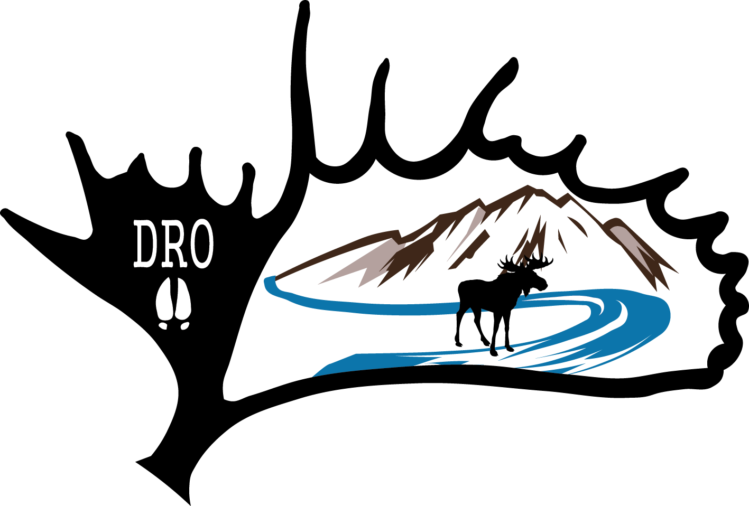 | Morgan Sheppard  Box 1971  Fort Nelson, B.C.  CANADA  E-Mail: mdsheppard80@gmail.com

DUNEDIN RIVER OUTFITTERS HUNTING APPLICATION

Please print, complete and return with a deposit to reserve hunt dates.

Name: _________________________________________ Address: _________________________________________________

City: ________________________________________ State/Province: _________________________________________________

Country:_______________________________________ Zip Code/Postal Code: _______________________________________________

Home phone: __________________________ E-mail: ________________________________________ Drive or fly? _______________

Date of birth: ____ month ____day _______year Height: _________ Weight: _________

Medical concerns: __________________________________________________________________________________________________

__________________________________________________________________________________________________

How do you rate your physical condition? Poor: ____ Fair:____ Good:____ Excellent: ____

Food allergies: _____________________________________________________________________________________________________

Type of hunt: _____________________________________________ Hunt date: ___________________________________
_____________________________________________

Please put an (X) on the tags and licenses you would like purchased on your behalf. Prices are all in Canadian currency.
Non-Resident hunting license $75.00 | X | Deer $125.00
Non-Resident Alien hunting license $180.00 |  | Sheep $620.00
Non-Resident Hunt Preservation Fund $200.00 | X | Caribou $230.00
Moose $250.00 |  | Wolf $50.00
Elk $250.00 |  | Wolverine $40.00
Mountain Goat $350.00 |  | Upland game birds $50.00
Black Bear $180.00

___________ ___________________________
Date Signature

- All licences and species tags must be acquired prior to the hunt. All licences are guaranteed.
- Tags and licenses mentioned above do not include 5% GST and are subject to Government change.
- Payment accepted only in: cash, traveller or certified cheques, or money order. All certified cheques or money orders must be payable to Dunedin River Outfitters.
- A 50% deposit is required by January 30th to book all hunts. The balance of the hunt fee is due 60 days before the hunt starts.
- Notice of cancellation must be in writing and received by us 60 days before start of the hunt. Any less forfeits down payment.
- Deposits will be refunded less a 20 % service charge. A hunter may send a replacement person at no loss.
- We are often asked about gratuities. Should you decide to do so, basic guidelines suggest between 5% to 10% or equal to licenses and tags fees.

For Dunedin’s use only
- Cost of hunt $______________
- One on one guiding services $______________
- Non-hunter - $300/per day $______________
- Add 5% GST $______________
- Tags/licenses $______________
- Deposit amount $______________
- Balance owing $______________

